**Task 01: Write a program that prints triangle using loops in python.**

**Code:**

q=int(input("Enter the number of stars in central line\n"))

for i in range(1,(q+1)):

 print(" "*(q-i),"* "*i)

**Output:**

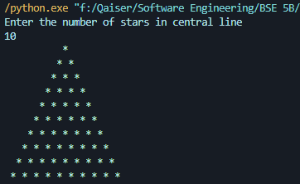

**Task 02: Write a program that prints Fibonacci series.**

**Code:**

def fibo(*n*):

   if n <= 1:

       return n

   else:

       return(fibo(n-1) + fibo(n-2))

*# take input from the user*

nterms = int(input("How many terms of fibonacii series? "))

*# check if the number of terms is valid*

if nterms <= 0:

   print("Plese enter a positive integer")

else:

   print("Fibonacci sequence:")

   for i in range(nterms):

       print(fibo(i))

**Output:**

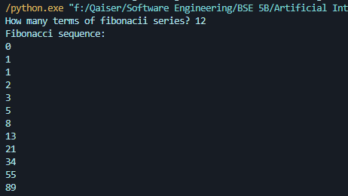

**Task 03: Write a short program that prints each number from 1 to 100 on a new line.**

* **For each multiple of 3, print “SAM" instead of the number.**
* **For each multiple of 5, print “SUNG" instead of the number.**
* **For numbers which are multiples of both 3 and 5, print “SAMSUNG" instead of the number.**

**Code:**

def samsung(*value*):

    x = 1

    while x <= value:

        if x % 3 == 0 and x % 5 == 0:

            print("SAMSUNG")

        elif x % 3 == 0:

            print("SAM")

        elif x % 5 == 0:

            print("SUNG")

        else:

            print(x)

        x += 1

samsung(100)

**Output:**

